**NORTHERN YOUTH FOOTBALL & CHEER**

**Board Meeting Minutes of May 24, 2022**

**Location: Meeting conducted at Dillsburg VFW**

***ATTENDANCE:***

**Members in attendance:**

Ed Whitt, Ross Fronk, Amanda Divittore, Ben Hellmold, Danielle Peters, Tony Stump, Jena Inscoe, Nichol Hare, Luke Macke, Jason Stacknick, Mandy Myers

**Attendance by non-members/public:** Coach Thomas Miller of Northern York County High School

***WHEREAS*** the NYFC Board Meeting was called to Order by Ed Whitt at approximately 7:45 p.m., who formally made motion to begin along with a second the motion. A subsequent Motion was made to accept the Treasurer’s Report, a second motion was made and all members voted in favor to adopt the Treasurer’s Report for the preceding month as of the date of this instant meeting. The account balance is $25,000.00 (although not all bills have cleared).

1. **CHEER REPORT:** *(Danielle Peters present)*

**REGISTRATION (as of 5/22/22)**

1. Polar Cubs - 3

2. Smurf - 18 3.

PeeWee - 17 4.

Pony - 11 5.

Midget - 9 Total - 58

**COACHES**

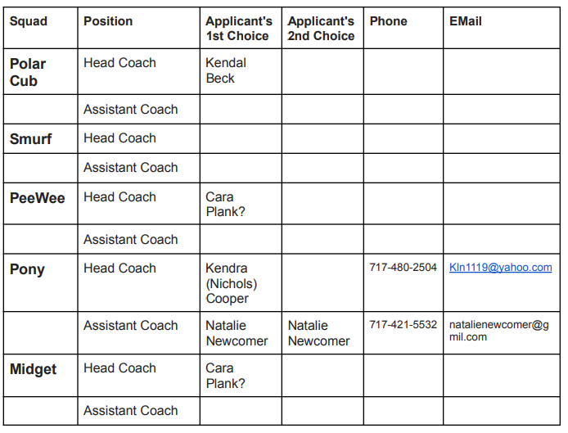

● Recruiting email sent May 19. We have received no applicants as a result.

● Facebook ad submitted May 24

**UNIFORMS**

It was brought forward at the April meeting that the cheer uniforms may need to be replaced. Upon my inspection, I feel they may be salvageable with proper cleaning. I have given two sets of the uniforms to local dry cleaners, who believe they will be able to remove stains and properly cleanse them all. They are to get me exact prices for the total cost early next week.

A vote was taken and the Board was in unanimous agreement for the uniforms to be cleaned.

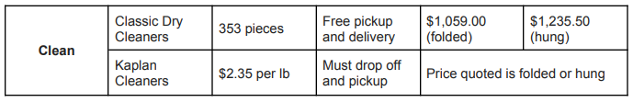

**CURRENT UNIFORM INVENTORY**

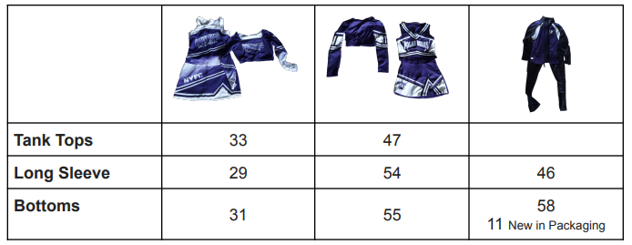

A discussion was held regarding the uniforms for the Polar Cub Squad. We will explore the possibility of utilizing uniforms that we have on hand to offer the girls to wear during the season.

**POM POMS**

The pom poms that we have are in need of being replaced due to normal wear and tear along with fading. A vote was taken and all Board members were in favor of purchasing new pom poms for $659.40.

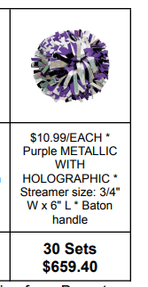

**CHEER BOWS**

The Board voted unanimously for the purchase of bows. The approximate total amount being $411.00.

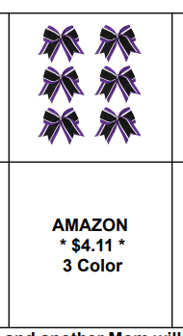

All bows will be plain ribbons, Danielle and another mom will add the logo and rhinestones.

**UNDER SHORTS**

1 Pair provided for each cheerleader in a traditional uniform. The Board votes and is in unanimous agreement with the purchase of undershorts for the program. A total approximate expense of $640.00 for 80 pairs of shorts.

**ADDITIONAL UNIFORM ITEMS**

Shoes White sneakers required and supplied by parents/guardians. Will provide parents/guardians with resources to where they may purchase shoes. Socks White no-show ankle socks required and supplied by parents/guardians

**CHEER CAMP**

The Northern HS Squad is hosting a cheer camp on Saturday, June 4. I have spoken to their coach and she is willing to help us hold another cheer camp on July 23 or 30, allowing our girls to meet each other and get a preview of their cheers and dances, and learn jumps.

Pizza lunch provided.

Will seek pizza donations from a local vendor

Will need drinks, plates, napkins and chips.

**MINI CHEER CAMP/UNIFORM HANDOUTS**

July 23 or 30

Do we charge? $15

A vote was taken and all were in favor of charging $15 per cheerleader for the Mini Cheer Camp

**TUMBLING CLASSES AT FLIPPING OUT TUMBLING**

Contact has been made with FOT, they are reviewing their calendars to see if they can make tumbling sessions with our cheerleaders work (as they have in previous years). I will update you all once I have more solid plans.

**WELCOME LETTER/EMAIL TO BE SENT OUT**

Will include introduction, invitation to coach (for applicable squad), Mini Camp/Uniform Handout/Meeting info, schedule, uniform and other items needed, Game Changer Info, etc.

**II. FOOTBALL REPORT:** *(Jason Stacknick present)*

* Classroom sessions with Ponies and Midgets (to take place at the SLC):

Sunday June 26 6:00PM

Sunday July 24 6:00PM

Purpose: Installation of key offensive terms, rules, and concepts. These meetings are anticipated to last approximately 2 hours.

* Registration Numbers:

Smurf 9

Pee Wee 25

Pony 21

Midget 23

* Adoption of Player/Parent Contract for Pony and Midget levels:

Jason will be preparing a draft of this contract for the Board to review. The concept is to set a level of expectation for the parents and players regarding playing time, safety, and conduct.

Jason will be looking into the use of South Mountain Elementary’s Cafeteria for a time simultaneous with the start of practices so that we can conduct a parent meeting.

* Dicks voucher $250 (where do we want to spend the money, what do coaches need);

The Board mutually agrees to lot $100.00 to mouth guards that we can distribute when needed during the season.

* Head coaches have been notified of equipment handout date and times and it was recommended that they be there to introduce themselves to parents and kids. Jena, Amanda, Nichol, and Jenni will be present at check-in to collect mandatory forms, fees, and to distribute volunteer letters and flyers for upcoming activities and events.
* Meet the team night is going to take place on August 25, 2022. More information on this to come.
* There was a request from the Pee Wee squad for the Board to purchase water bottles and playing balls.
* There was a request from Board President to have the photography crew create extra badges for individuals who may need to be present at the time of games.
* PigSkin Prep June 13 – June 16 8:30 to 11:30

Coaches- Ed Whitt, Tony Stump, Mason Hayes

**III. PARENT RELATIONS COMMITTEE REPORT:** *(Ed Whitt present)*

* No report at this time.
* See Football Report regarding parent meetings that we would like to host at the beginning of the season.

**IV. EQUIPMENT/FIELD MAINTENANCE COMMITTEE REPORT:** *(Ross Fronk present)*

**I. Recommended jersey and pants order for upcoming season:**

a. We need additional big sizes of pants;

b. Added two lineman numbers to our inventory (58 & 69) to accommodate for the CFA

rule change. We are currently fairly limited on lineman numbers;

c. Replacing Ryder Williams jersey that we donated;

d. Practice jerseys in this order are for replacements or jersey numbers in which we didn’t

have matches.

**Pants: Cost: $814.20 exclusive of shipping**

Qty: 26 youth @ $24.00, 6 adult @ $31.70

YM – 6

YL – 10

YXL – 10

AM – 6

**Game Jerseys: Cost: $849.34 inclusive of shipping**

Qty: 11 youth @ $62.50, 2 adult @ $64.00

#15 – YS, YM, YL, YXL

#58 – YM, YL, YXL, AM

#69 – YM, YL, YXL, AM

#87 – YXL

**Practice Jerseys: Cost: $525.56 exclusive of shipping**

Qty: 28 youth @ $11.77, 56 screen printed numbers @ $3.50

#10 – S/M (x2), L/XL (x2)

#15 – S/M (x2, L/XL (x2)

#25 – S/M, L/XL

#32 – S/M, L/XL (x2)

#33 – S/M, L/XL (x2)

#46 – S/M, L/XL (x2)

#53 – S/M, L/XL (x2)

#58 – S/M (x2), L/XL (x2)

#87 – S/M (x2), L/XL (x2)

**II. Helmets**

a. Awaiting response from Riddell with ETA on helmets.

b. If our helmets aren’t in by June 6th, we either move the date to Sunday, June 19 or hand

out helmets first week of HeatAcc.

c. We may have a large issue with helmets. If we don’t have enough, we can’t get new

ones. Riddell stopped selling helmets because they can’t produce them fast enough to

get them out before the season starts.

**V. FUNDRAISING COMMITTEE REPORT:** *(Nichol Hare present)*

* Gun Raffle tickets 250 taken by VFW, 23 taken by gun dealer. 500 total 274-500 our responsibility. $5000 to pay for guns. VFW Sponsor for game of chance. Got NYFC game of chance license as of 4/26/22. Ed reimbursed by check. Signature from superintendent of school for 50/50 at games.
* Lucky Lotto books voted to move forward. Prizes need to be discussed and voted on.
* Carwash and chicken BBQ pushed back until raffle and lotto done.
* Lucky Lotto raffle tickets given at registration (like baseball) for each kid. Most booklets sold get prize or drawing for a prize. Amanda says YES, first. All in favor

**VI. VOLUNTEER COMMITTEE REPORT:** *(Nichol Hare present)*

No report at this time.

**VII. CONCESSIONS COMMITTEE REPORT:** *(Mandy Myers present)*

* Minimize the list of volunteers and revise
* Looking into best Square options for credit card purchases
* Amanda will be involved in implementation of the Square program for observation and approval as it relates to the Board’s bank account.
* Discussions will continue regarding the purchase of a grill. Vote to be taken at some point prior to the start of the season.
* Weis and Giant each donated a $25.00 gift card.
* We received a donation of 120 bags of potato chips from Martin’s.

**VIII. REGISTRATION COMMITTEE REPORT:** *(Jena Inscoe present)*

No report at this time. See Football report for registration numbers.

**IX. PHOTOGRAPHY COMMITTEE:** *(Jenni Stacknick present)*

No report at this time, however, dates for upcoming events are going to be carried over into these meeting minutes.

* NYFC Picture Day; Saturday August 13, 2022 from 8 AM – 12 PM was approved at the Northern School Board Meeting on Tuesday, April 19, 2022
* Lenny Yospa confirmed via email to Jenni (forwarded to executive board members) that this date and time was reserved for NYFC photos
  + More detailed information and communication closer to photo date
* Proposed schedule:
  + Smurf Football & Cheer - Arrive 8:00 AM
    - Football players and coaches assemble at back bleacher steps near concession stand for team photo (in bleachers under home side press box)
    - Cheerleaders and coaches assemble on track for individual photos on field (scoreboard or banner as background)
    - Football players and coaches will exit bleachers using the front set of steps toward main exit and move to track for individual photos (scoreboard or banner as background)
    - Cheerleaders and coaches will exit field and move to the ramp at the far end of the bleachers to assemble for team photo (in bleachers under home side press box)
  + PeeWee Football & Cheer – Arrive at 8:45 AM
    - Follow the same schedule as above
  + Pony Football & Cheer – Arrive at 9:30 AM
    - Follow the same schedule as above
  + Midget Football & Cheer – Arrive at 10:15 AM
    - Follow the same schedule as above
  + Family shots (coaches/kids) and special requests – Arrive at 11 AM (these photos will be at this time – anyone wishing to participate can return at 11 AM. This is an effort to keep regularly scheduled photos moving quickly and with less confusion.
* Considerations
  + Photo Banner
    - Does youth sports photo have a green screen to edit backgrounds? – Jenni will follow up.
    - If not, does someone have a contact who could make something for us to use for photos? We could display it at the home games as well for free advertising.
    - We can try the scoreboard again but as far as I can remember, it’s never really been in the background (maybe it’s just too high to shoot into the photo).
  + Ladder – will the photographer taking team photos in the bleachers need a ladder? – Jenni will follow up.

**X. CFA UPDATES FROM APRIL 2022 MEETING:**

* Voting on the Bylaws, the CFA will need at least 50% to move the vote forward tonight (there will be a final vote in May to revise the bylaws, this gives each organization time to do some research and share information with their board members).
* Vote in May will need 2/3rds approval to revise the bylaws.
* Started at article 2, although that is for the CFA Commissioners to vote on not the teams, the CFA commissioners voted not to change the current structure to 2 conferences with 4 divisions like the NFL, therefore all associated changes throughout the bylaws were voted “no.”
* Realignment formula review, change is that you get 2 points for winning simi finals and 3 points if you win the Super Bowl, unanimous vote yes, by CFA commissioners to update Realignment formula
* Voted no on the proposed new Divisions
* Recommend deleting the fee to the CFA for field use during playoffs, voted to yes to delete the fee to the CFA for hosting teams to.
* The CFA needs teams to step up and host a simi final and or super bowl.
* The CFA voted yes to add language to support not playing varsity players at the JV level in their varsity position (this was a recommendation by our team).
* CFA met with the PIAA officials
  + They need to split the new and more experienced officials.
  + They felt that the older officials would stop blacking out the Midget games
  + Order of play will change, Pee Wee, Midget, Pony, non-negotiable, this is the order
  + Times will change too.
    - Pee wee 6 minute quarters
    - Numbering rule for lineman will be between 50 and 79.
  + Pee Wee will start at 12:00PM on Sundays, Saturday will be 4 PM.
  + Midget start time at 1:30PM or 10 mins after the last game.
  + Only 6 coaches with badges, all other personnel must have badge (get visitor badges), youth water boy does not need a badge. No other level of players are allowed to have on the sound line.

**NOTE:** The CFA met with the PIAA Referees that abide by the National Federation of High School guidelines and they stated that the information below is nonnegotiable for the 2022 season and moving forward. There were several teams upset although, it was stated that the youth league is supposed to be introductory and therefore, should not be an issue.

Badges, we will need to request 3 additional badges per team, each badge will say NYFC Sideline Support, they will be given to the HCs from each level who is responsible to hand out prior to their sideline support per game.

**PEE WEES:**

1. **6-minute quarters** – Per National Federation of High School (NFHS) Guidelines
2. PUNT RULE – Move the ball 20n yards from existing spot – or – half the distance to the goal line if across mid – field.
3. ONLY 6 TOTAL COACHES WITH CFA BADGES ALLOWED ON SIDELINE – other adults (photographer, stat person, EMT, etc.) must also display a CFA badge…. Youth water boys/girls do not need one.

NO OTHER LEVEL PLAYERS ON THE SIDELINE DURING CONTEST

1. MANDATORY ** - FOLLOW NFHS NUMBERING RULES – EX. OFFENSIVE LINE #’S MUST BE 50 – 79.
2. ***It is suggested*** that kneel-downs will occur when the lead is deemed insurmountable & the time remaining is less than 2 minutes for safety reasons.
3. ***It is suggested*** that after a score, the scoring team has the option to kick – off or have the ball placed on the RECEIVERS 40 yd line.
4. PEEWEE START TIME IS 12 PM

**PONY / MIDGETS:**

1. **7-minute quarters PONYS –** Per NFHS Guidelines
2. **8-minute quarters MIDGETS** – Per NFHS Guidelines
3. ONLY 6 TOTAL COACHES WITH CFA BADGES ALLOWED ON SIDELINE – other adults (photographer, stat person, EMT, etc.) must also display a CFA badge. Youth water boys/girls do not need one.

4.MANDATORY** - FOLLOW NFHS NUMBERING RULES

**EX. OFFENSIVE LINE #’S MUST BE 50 – 79.**

5. It is suggested that kneel-downs will occur when the lead is deemed insurmountable & the time remaining is less than 2 minutes for safety reasons.

6. MIDGET START TIME IS 1:30 PM – OR 10 MINUTES AFTER PREVIOUS GAME.

P0NY START TIME IS 3:00 PM – OR 10 MINUTES AFTER PREVIOUS GAME.

* 8-minute halftimes to allow time for cheer routines.
* Yard markers on the home side of the field.
* If a player is a STRIPER, they must play as a STRIPER in the ALL-STAR games as well.

JV LEVEL

1. 10-minute running clock.
2. Keep existing timing in place.
3. No kick offs or punts in Peewee JV games- place the ball on the 35 yd line to maximize reps.
4. JV level coaches can be on the field for (1 coach on field, up to week 3) number of games, for all 3 levels, no score on the board for any JV games.

**Additional:**

Smurf Start time, will depend on host team.

Enforcement rules:

Sideline “Chain Gang” has to be on the host team’s sign.

All players will HAVE KNEE PADS, that cover the Knees

Full number front and back on jerseys is a must, they are concerned about the ineligible players down field, our linemen will have to have be 50-79. Each level (if possible) should have some extra jerseys (best if you have a lineman, running back, and specialty player numbers). We are authorized to use pennies/practice jerseys as long as they have numbers on front and back and align with their primary positions being played. Example, at the Pony level our full back (#35) is injured during the varsity game, we decide to replace with our offensive guard (#65), we have to give number (#65) a full back number (#37 or some other number).

**XI. NEW/CURRENT BUSINESS:**

Upcoming Dates for NYFC:

June 6 – 10, 2022 Pig Skin Prep Camp

June 6, 2022 Equipment Handouts (6-8 PM)

Make up Day Equipment handout

July 25, 2022 Practices Starts (Acclimatization week)

August 13, 2022 Team Photos at Bostic

August 26, 2022 Possible Meet the Team Night at Bostic

**COMMITTEE REPRESENTATIVES**

The President has offered assignments of upcoming committee chairs that will need to be filled by Board members in lieu of having a volunteer commit to the vacancy:

1. Awards Committee – Ed Whitt
2. Concessions Committee – Nichol Hare
3. Equipment - Ross Fronk
4. Field Maintenance - Ben Hellmold
5. Registration Committee – Jena Inscoe
6. Picture Committee – Jenni Stacknick (The Board acknowledges that Jenni has graciously volunteered to accept this committee chair and we thank her for the same.)
7. League Committee – Jason Stacknick
8. Parent Relations Committee - Ed Whitt
9. Farmer’s Fair Committee – Ed Whitt

*A Motion was made by Ed Whitt to adjourn the meeting, a second motion was made and all were in favor to conclude at 9:15 p.m.*